

**Our Children Need More Time for Lunch**

**LEGISLATIVE REQUESTS:**

* Require an audit of the amount of time that students have for lunch in elementary, middle and high school.
* Request that state legislators consider a [mandate for longer meal times at schools](http://www.motherjones.com/tom-philpott/2012/04/school-cafeteria-11-minute-lunch), similar to their mandate for minimum amounts of physical activity.

**WHY?**

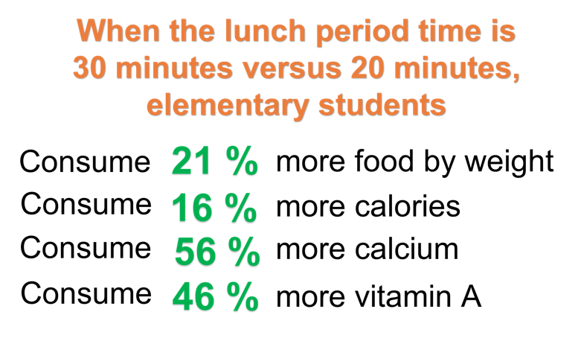

* **Shorter Lunch Times Means Higher Rates of Obesity and Fewer Fruits and Vegetables Consumed:** Short lunch times and rushed eating have been associated with detrimental effects on students, including obesity (58).
* **Every Minute Counts:** Students who had fewer than 24 minutes to eat, consumed significantly less of their entrees, vegetables, and milk compared to students who had at least 25 minutes (52). Students were significantly less likely to select fruit for their trays if they had less than 24 minutes to eat.
* **Longer Lunch Times Decrease Food Waste:** School policies providing for at least 25 minutes of seated time may reduce food waste (52). In a survey of school cafeteria managers, 44% reported “not enough time to eat” as a factor in plate waste (53). A screenshot of a cell phone

  Description automatically generated
* **New York City Should Take the Lead:** Across the country, 5 [states have already implemented legislation](http://statepolicies.nasbe.org/health) requiring at least 20 minutes to eat after sitting down, and 6 states have implemented legislation requiring “adequate” time to consume meals. New York state falls into the latter group of states (63). New York City can serve as a role model by improving the sustainability of healthy eating in a supportive school environment.